Service Contract Subscription Billing Process is creating invoice with wrong currency
Issue: UK Subscription currency is GBP but Invoice has currency AUD
Steps:
- Created a subscription using UK Customer (Currency GBP)
- Billing Schedule shows currency = GBP (screenshot 1)
- After Subscription Billing Process is completed, the Sales Invoice Proposal shows currency = AUD (screenshot 2)
Screenshot 1: Currency=GBP
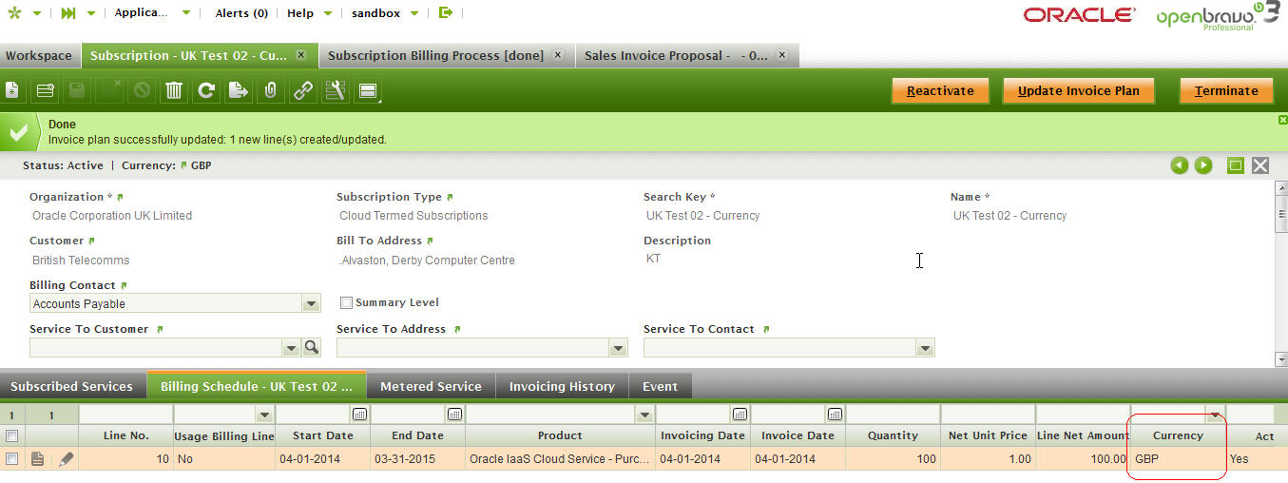
Screenshot 2: Currency=AUD

