I am this transaction on Demo Online Database
First of all, I check account 17000 in General Ledger Reports
Time filter from 01-12-2003 to 31-12-2009
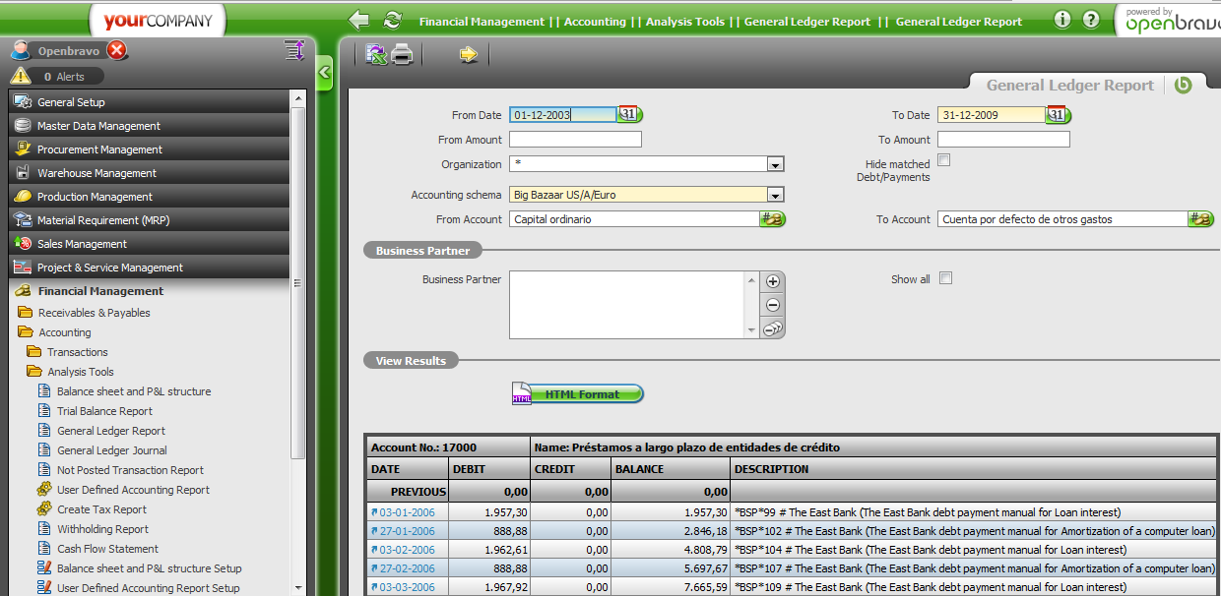
I saw that system have already some transactions in Jan, Feb, March, …. of 2006

Then, I checked again with trial balance report. Date filter from 01-03-2006 to 31-12-2009
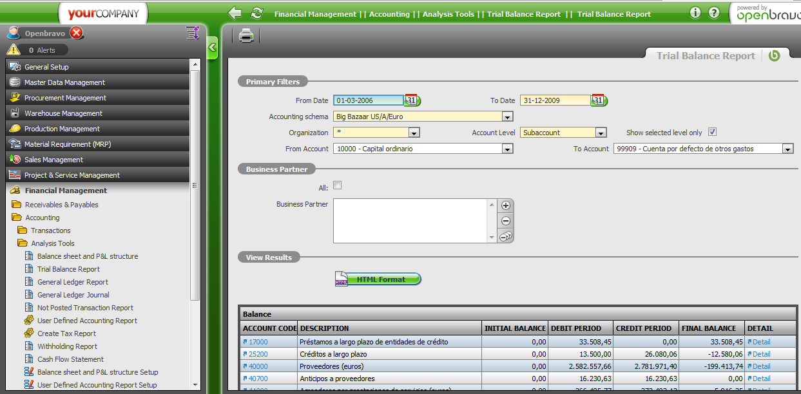
I thought that it must exist one Initial balance value. But, the report, this account obtains 0 at Initial Balance. Please check again this report on the demo database

