Price list is marked as including taxes as displayed in the picture below.
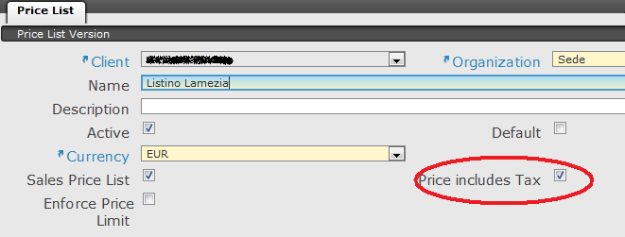
Below the list of prices related to the price list “Listino Lamezia”. The “Roma Colore Base” product has a price of € 290,00.
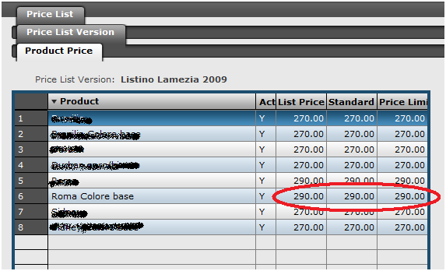
An order is created for customer Antonio and the selected price list is Listino Lamezia.
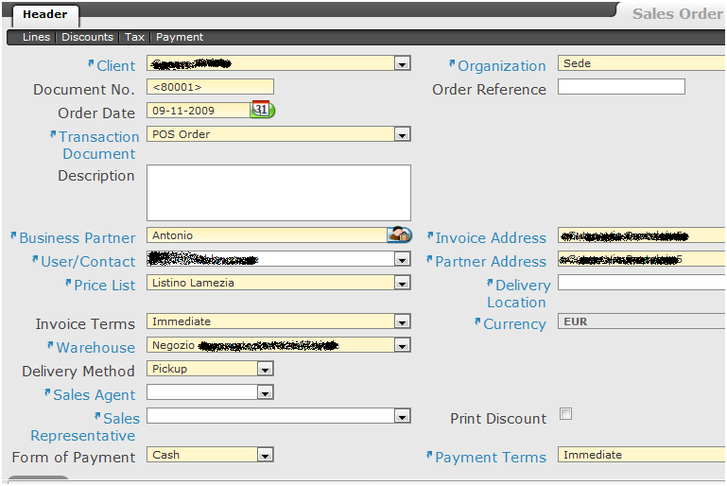
A line for product Roma colore base is created and the price is correctly set to € 290,00 according to the price list. Please note that the application shows also VAT 20% which is the default tax rate defined in the system.
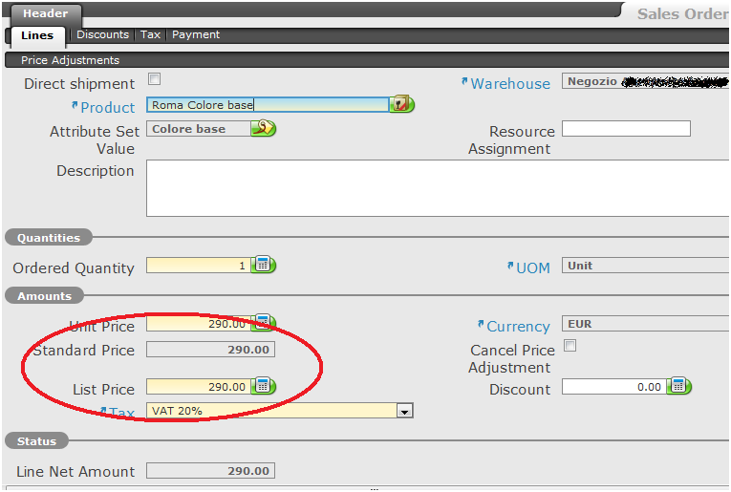
In the tax tab it is displayed that a tax is applicable and the amount is € 58,00 that is exactly 20% of € 290,00. In this window just above the grid, the total price 348,00 is displayed.
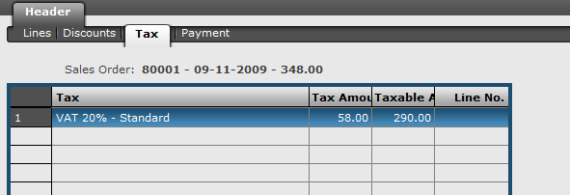
Once coming back to header tab, the grand total amount is € 348,00.

