1.- Edit Customer
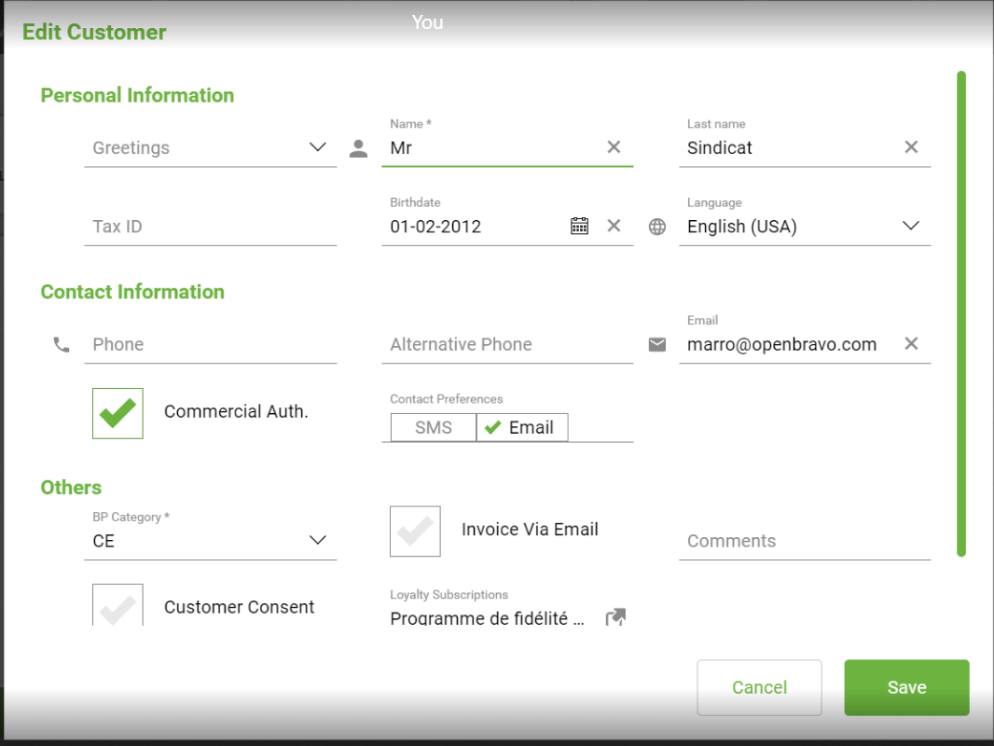
2.- View Loyalty Suscriptions
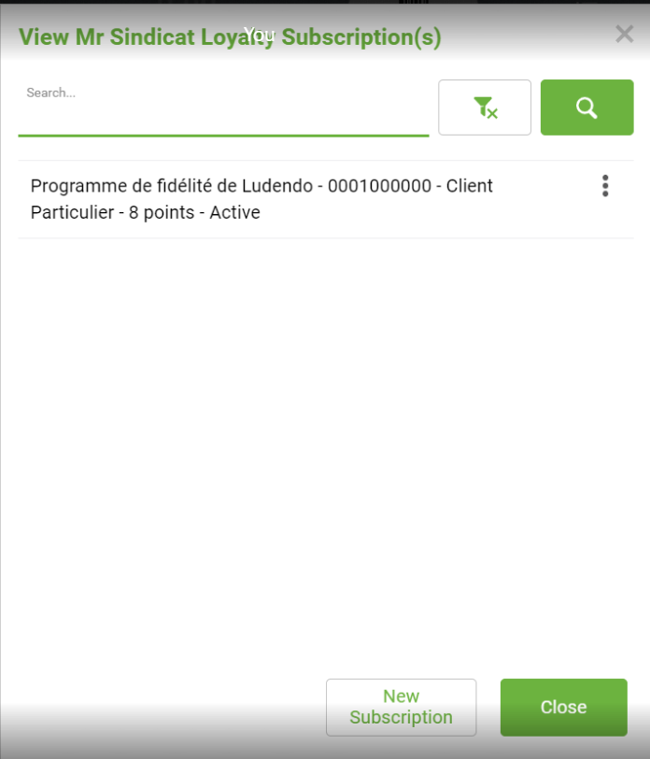
3.- Closing Loyalty suscriptions by the cross up-right you go to View Details
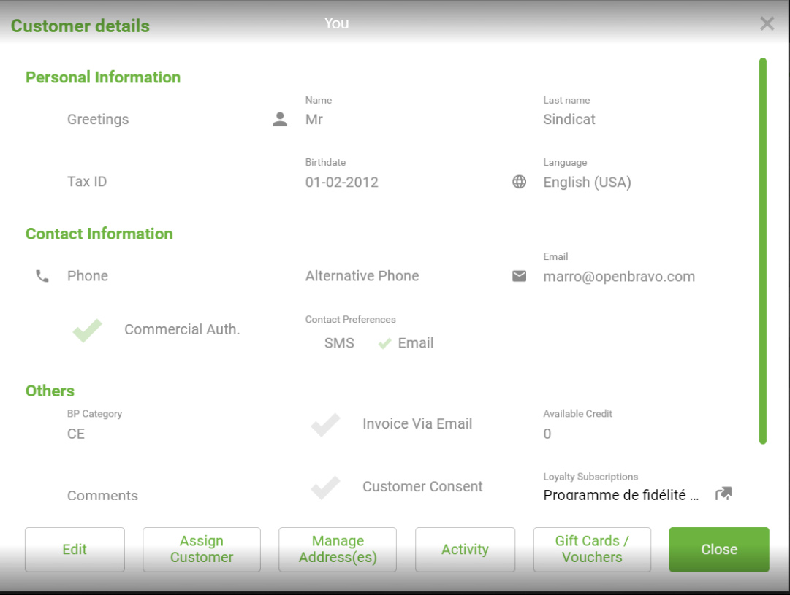
4.- And closing this window by the cross up-right you found:
