Note that this test has been done fully online.

Before selling the product: Stock is at -1 (!) in Sales bin PMA-PA001 and at 1 in the PMA-SCM-GIT1 bin, totaling to 0.
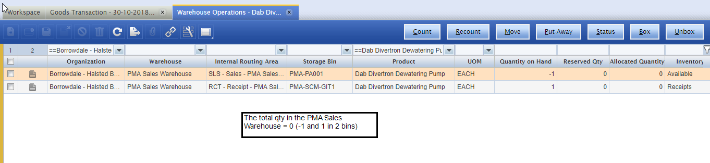

Having a total to 0, does not allow to add the product to the ticket. OK sofar.
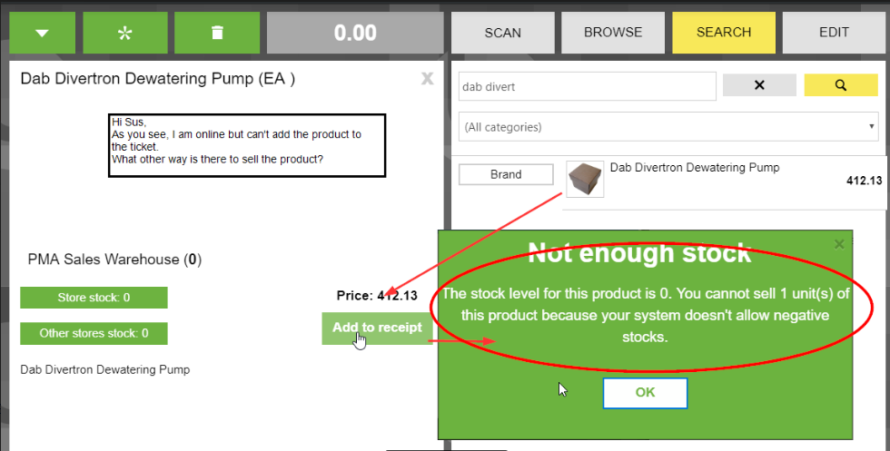

Adding stock in PMA-SCM-GIT to 5, leaving the sales bin to -1.
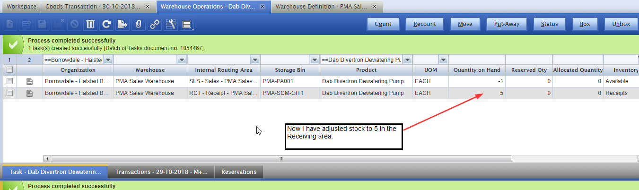

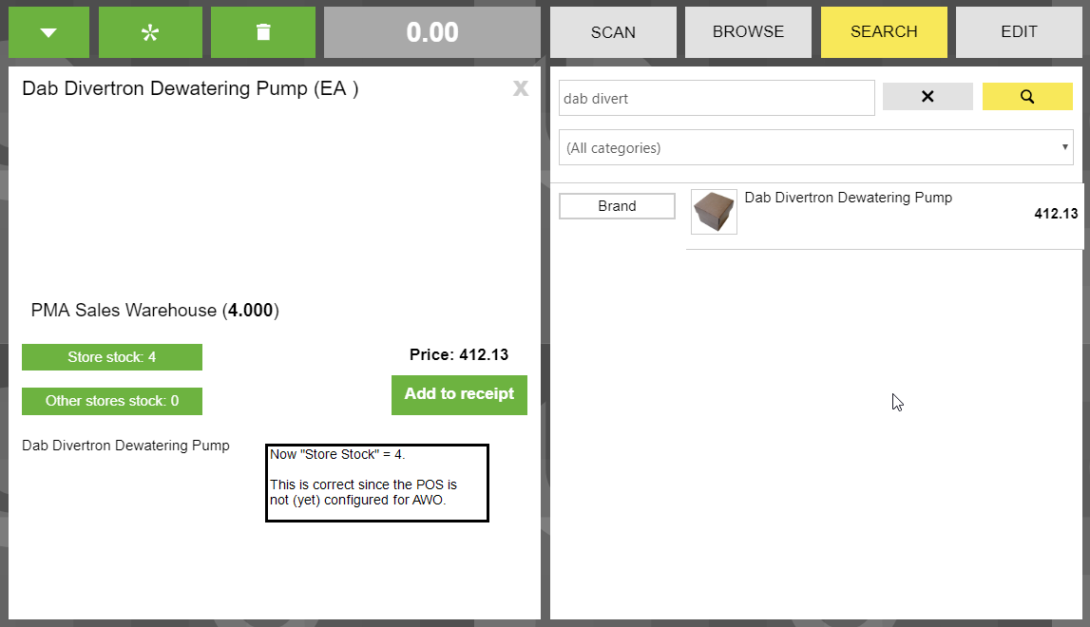

Adding the product to the ticket and payment…
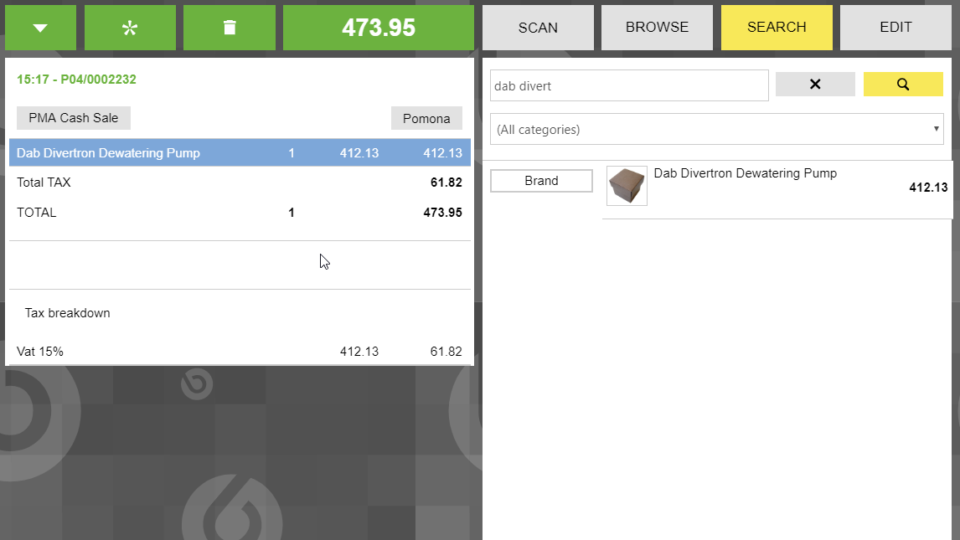

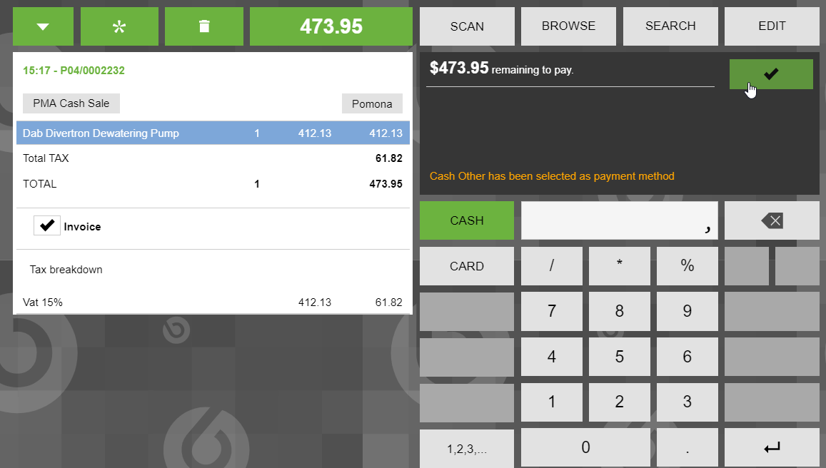
…brings the store stock to 3
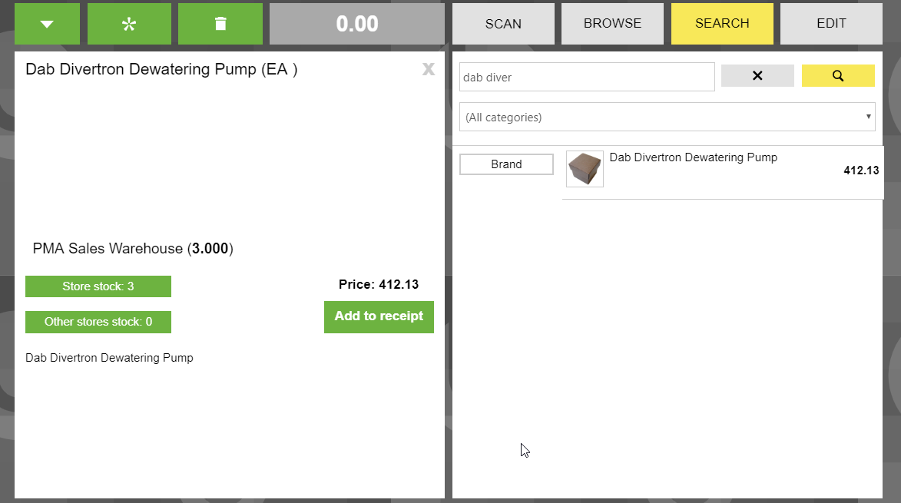

Namely 4 in PMA-SCM-GIT (just old 1 from the previous 5) and still -1 in PMA-PA001 = 3
So: without the AWO-setup in the POS terminal, stock is taken from the bin with a positive qty.
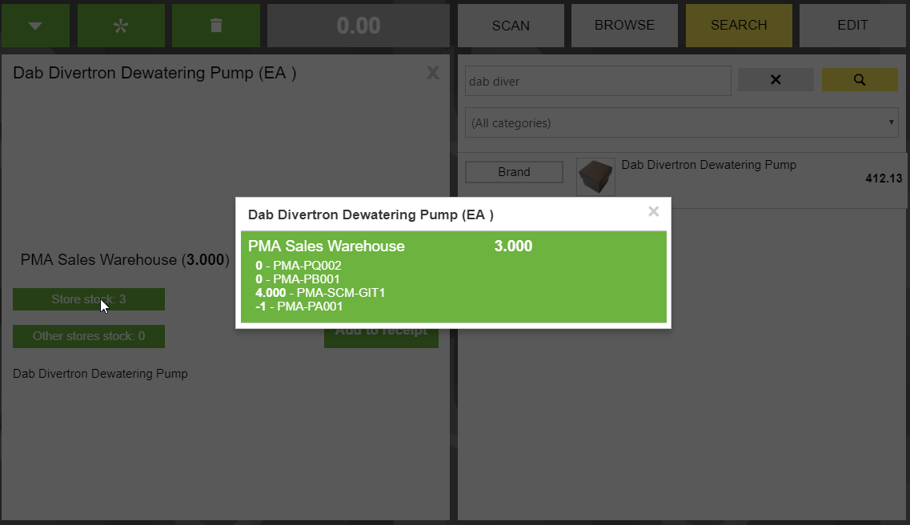

Now the AWO setup is done. The POS can only sell from the IRA for SALES, which is the bin PMA-PA001.

Since the Store Stock is 3, I can add the product to the ticket. This is wrong. The “Store Stock” should only see the stock in the IRA of the AWO-setup… Or give more info like “Floor Stock -1, Store Stock 3) (where “Floor” = The IRA in the AWO-setup of the POS and “Store” = The entire whse.)
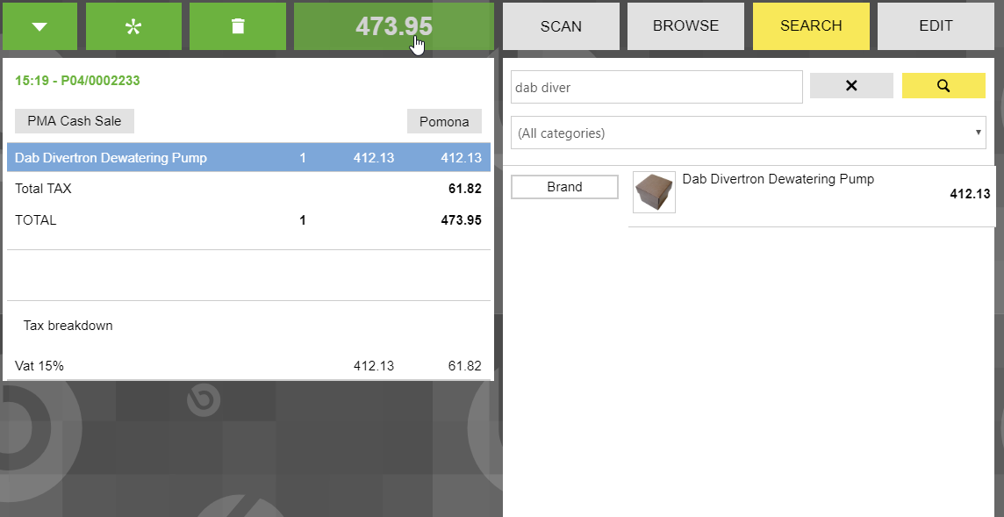

And pay:
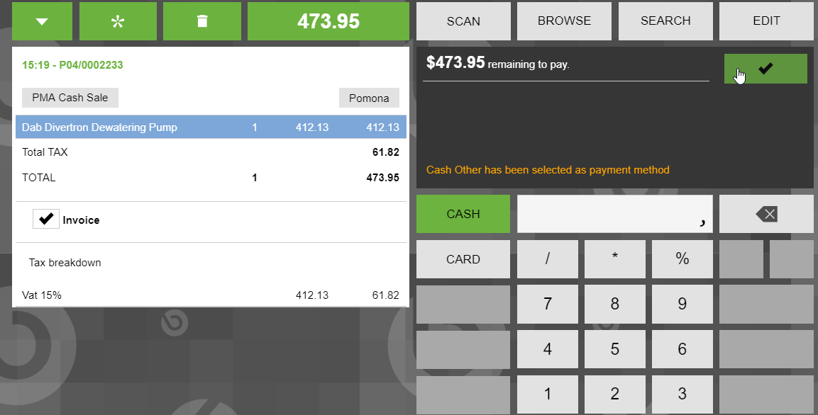

Now the stock is reduced from the correct bin (in the IRA for sales),
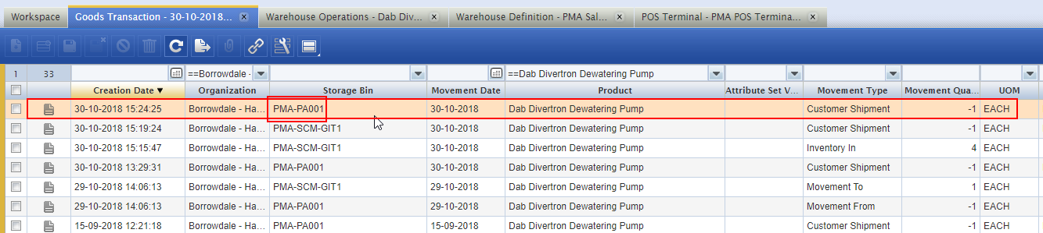

But leaving the quantity in this bin to -2!
This is wrong: The inventory status “Available” does not allow to be negative. So any sale that results in negative qty should be stopped by the system (if online)
