The issue is reprocible in this environment:
https://livebuilds.openbravo.com/retail_modules_pgsql_pi/web/org.openbravo.retail.posterminal/?terminal=VBS-1#retail.pointofsale
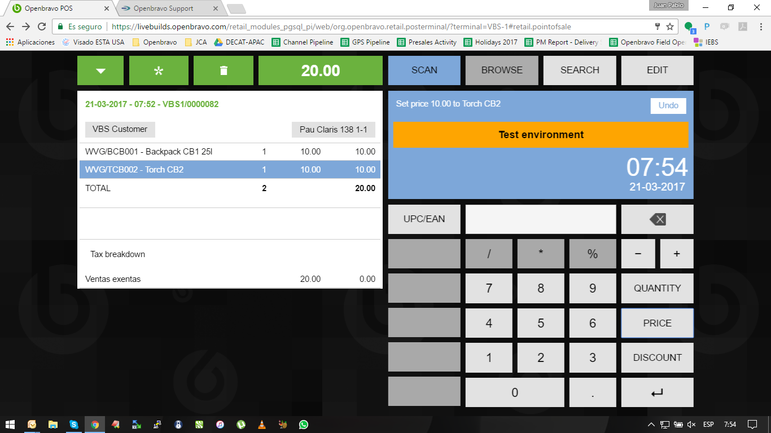
Steps:
- Create a discount & promotions of Combo type, with 2 families, each family with a Fixed Price Type of 100, for example. Price should be higher than the current price list of the products.
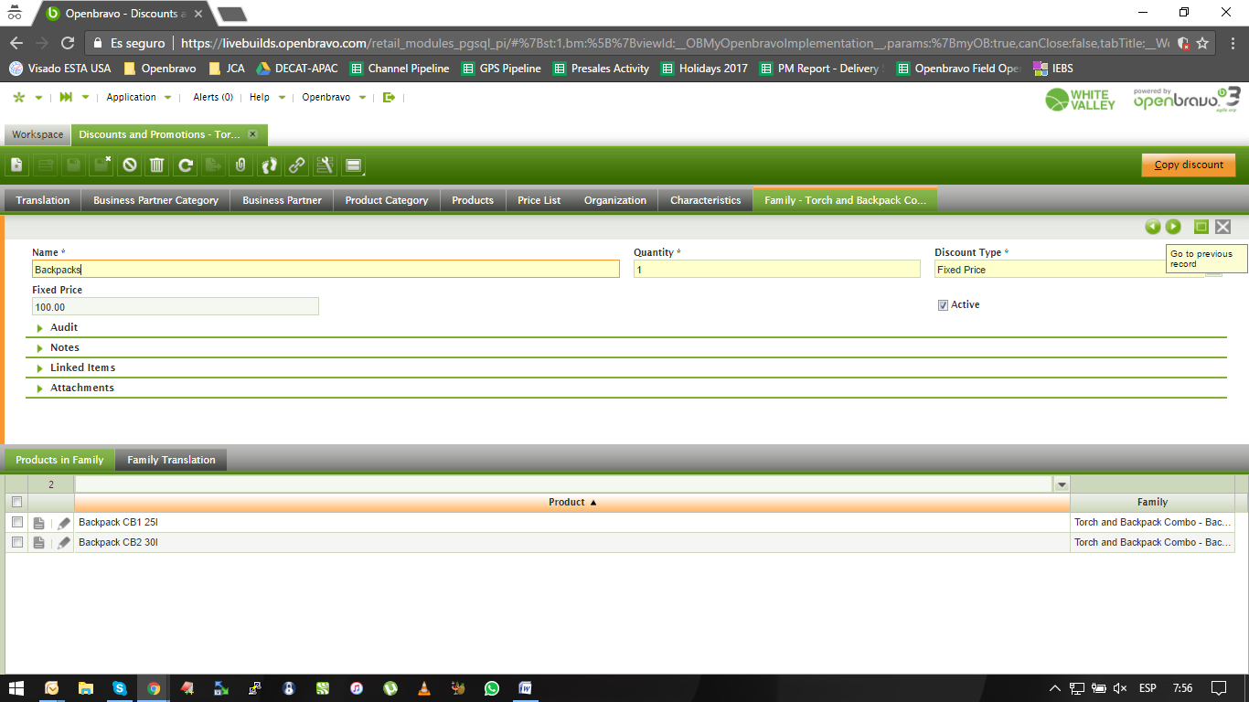

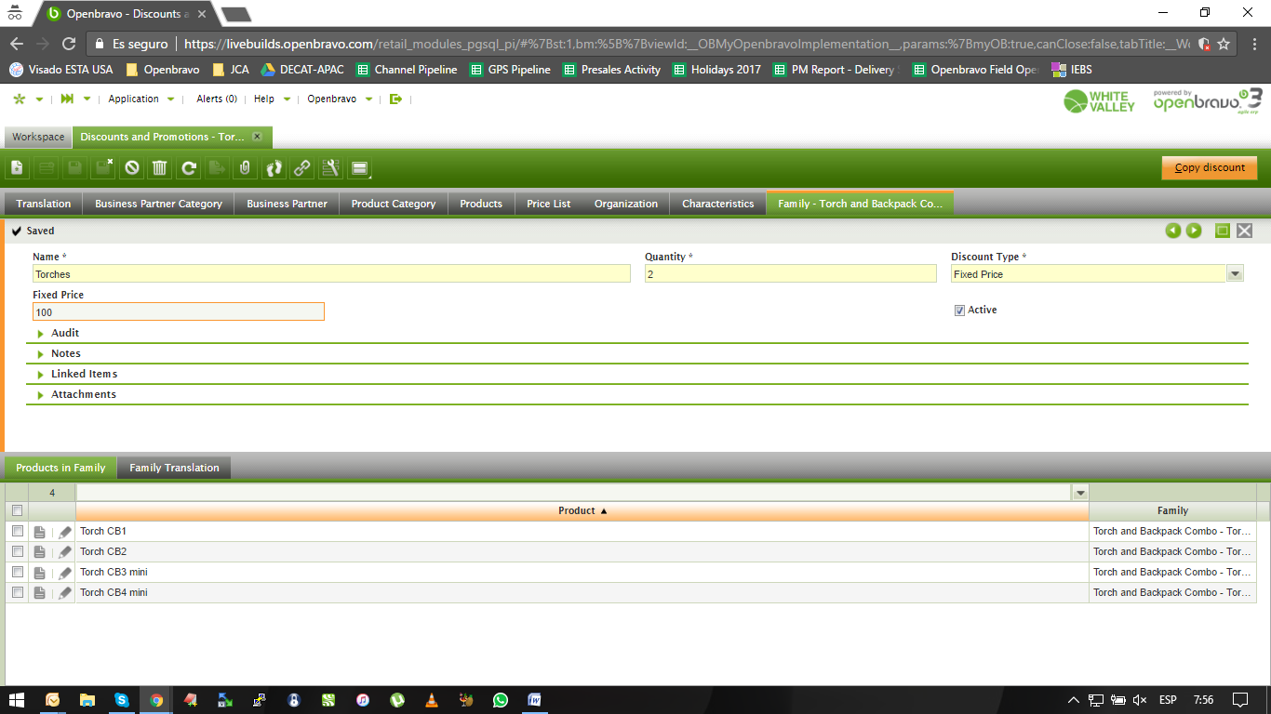
- Once it is done, go to the pos terminal and select the combo created.
- The system applies the combo. The combo should not be applied if the combo price (fix price is higher than the sum of the current price). In fact, the system is applying a positive discount (second line)
Note that this issue happens also with: combo fix price, and packs
